BASMU 2
MEDICAL ASPECTS OF DEPLOYMENTS TO POLAR REGIONS
British Antarctic Survey Medical Unit (BASMU)

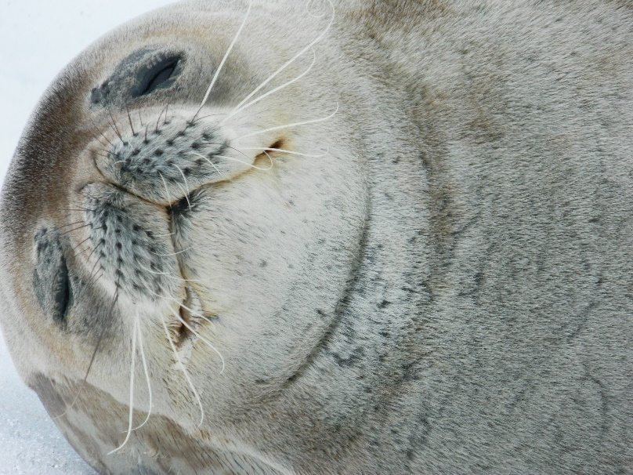

About This Guide
This short guide is for anyone heading to work with the British Antarctic Survey (BAS) or in partnership with them—including those from other organizations. It gives an overview of the key medical considerations when living and working in the Arctic or Antarctic. It’s not meant to be a full medical manual, but a helpful starting point. If you have any health-related questions, the BAS Medical Unit (BASMU) team is always happy to help.
Please read this guide before filling out the medical forms. It’ll help you understand how we approach medical assessments and why we ask for certain information. That way, we can fairly and accurately evaluate your fitness for deployment.
What’s Inside
- About BASMU
- Medical Facilities During Deployment
- Medical Requirements for Polar Work
- Health Conditions That May Raise Concerns
- The BASMU Medical Process
- Confidentiality and Medical Records
- Lifestyle and Health in Polar Environments

Quick Reminders Before You Go
- Bring Enough Medication: If you take medication regularly, make sure you pack enough for your entire deployment and delays. Contact BASMU if this becomes difficult.

- Personal Health Kit: Bring some high-SPF sun and lip cream (SPF 30 or higher), cold/flu relief meds, simple analgesia, over the counter products that you would use at home and motion sickness tablets for the journey.

- Dental Check-Up: Dental problems are one of the most common reasons people are evacuated early. Make sure your teeth are in good shape before you go.

- Be Honest About Medical History: Some conditions—like asthma, joint dislocations, or mental health issues—can be fine at the time of your exam but might flare up later. Please be open about anything that could impact your health during deployment, even if you’re feeling fine now.

About BASMU
- BASMU supports the health and wellbeing of everyone working with BAS, whilst deployed. We’re based and employed by University Hospitals Plymouth NHS Trust and include specialists in emergency and remote medicine, experienced nurses, and logistical experts.
Training
- Before you leave, you’ll attend a BAS conference in Cambridge where you’ll meet BASMU staff and take part in a first aid course tailored for polar work. Some team members also do advanced training on Dartmoor to assist with more serious medical issues in remote areas. Both courses are endorsed by the Royal College of Surgeons (Edinburgh).
Medical Facilities whilst deployed
- We have a trained doctor stationed at Rothera, Halley, and South Georgia bases, and on our ship whilst they’re in the South. As well as a military medic at Signy. These doctors and medics get additional training and are supported 24/7 by senior medics back in the UK.
- Medical services are extremely limited in the Polar Regions. Each base and ship have a basic supply of medicines and equipment—enough to handle common issues in a screened population. In the Arctic, medical facilities are even more sparse, with only minimal care available at certain locations like Ny-Ålesund and Longyearbyen.

What’s Required to Work in the Polar Regions?
- We aim to keep people safe while making sure the science gets done efficiently. That means identifying potential health risks early on and figuring out how to manage or reduce them.
- Most medical exams are passed without issue. Sometimes we’ll ask for more information or recommend you see your GP or specialist for further investigation or treatment. Very occasionally, someone may not be cleared for deployment—but this decision is never made lightly.
Why We’re Thorough
Getting sick or injured in the polar regions can have big consequences:
- Only one doctor is available at each site.
- Evacuations can be delayed by weather or distance—especially in winter.
- Evacuations can be risky to patients and the rescuers.
- Everyone plays a key role, and one person’s illness can affect the whole team.
- Medivacs can disrupt scientific work or cancel entire research programs.
Even if the summer weather seems mild (like a chilly day in Scotland), it’s the isolation and remoteness that drive our medical standards—not the temperature.
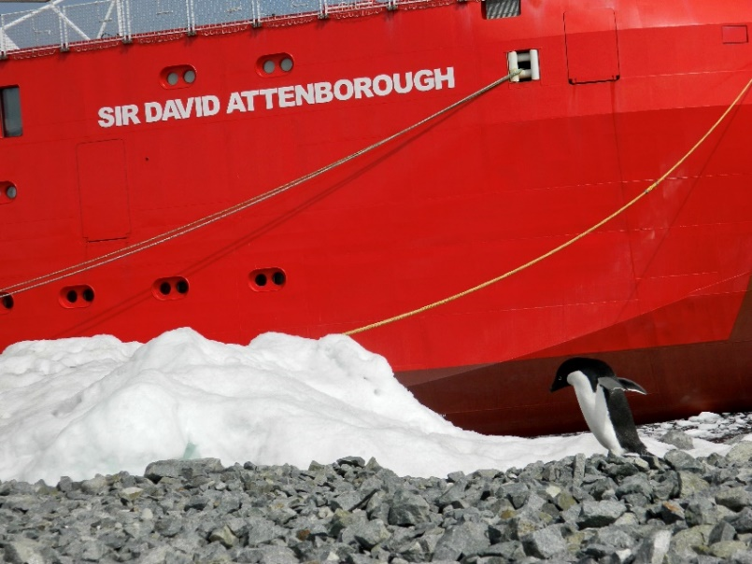

Health Conditions That Might Raise Concerns
Some conditions may make it difficult or risky to deploy, especially for overwinter stays. Others might be fine with monitoring or treatment. If you’re unsure, speak to BASMU before applying.
Conditions that preclude service  Decisions depend on many different factors but people with the conditions in this column will not be deployable on medical grounds. | Conditions which may preclude service  These will be assessed on an individual basis and in relation to the capacity to undertake activity/work in the anticipated environment.
Cardiac & Circulation problems  Angina & heart attacks  Leaky heart valves or rheumatic fever  Uncontrolled high blood pressure Heart rhythm abnormalities  Heart failure  Arterial disease (Arterial aneurysm or dilation)  Peripheral vascular disease  Anticoagulant medication | Treated abnormal rhythms Severe varicose veins Previous frostbite  Severe Reynaud’s disease Previous leg thrombosis Previous clot on the lung  Previous heart surgery
Respiratory (chest) problems  Recurrent pneumothorax  Cold induced or severe asthma Chronic bronchitis or emphysema Active tuberculosis  Sleep apnea/ use CPAP | Single episode of pneumothorax  History of moderate asthma
Gastrointestinal problems  Active stomach / duodenal ulcer  Liver disease  Pancreatitis  Untreated hernia  Inflammatory bowel disease | Previous exploratory abdominal surgery  Severe piles  History of stomach/duodenal ulcers
Genito- urinary problems  Recurrent kidney stones  Kidney failure | Single kidney stones (fully resolved)  Recurrent kidney infections
Neurological conditions  Epilepsy or fits  Non–traumatic brain hemorrhage in past  Unexplained episodes of loss of consciousness  Neuro degenerative conditions  Significant neurological deficit secondary to trauma | Previous brain surgery  Myalgic Encephalomyelitis  Chronic Fatigue Syndrome

Conditions that preclude service  Decisions depend on many different factors but people with the conditions in this column will not be deployable on medical grounds. | Conditions which may preclude service  These will be assessed on an individual basis and in relation to the capacity to undertake activity/work in the anticipated environment.
Metabolic Conditions  Type 1 diabetes  Cushing’s disease  Addison’s disease  Obesity BMI >35 | Well-controlled mild type ll diabetes (ENG 1 criteria) Other endocrine disorder Thyroid disease Obesity BMI 30-34
Musculoskeletal and rheumatological conditions  Rheumatoid arthritis  Ankylosing spondylitis | Recurrent back pain  Slipped disc  Systemic lupus erythenatosus  Severe knee problems  Recurrent dislocations (untreated)  Unstable joint  Frequent gout Lower limb amputation
Cancer and hematological disorders  Most cancers  Clotting or bleeding disorders  Anticoagulant medication  Active bone marrow disease | Treated cancer with low risk of recurrence Treated leukemia  Treated Hodgkin’s disease
Gynecological conditions  Current pregnancy | Pelvic inflammatory disease Ovarian disease
Dermatological conditions
Blistering skin diseases
Severe psoriasis
Mental Health Problems  Schizophrenia  Manic depression (Bipolar Affective Disorder) Personality disorder  Current Drug or alcohol abuse | Depression  Self-harm  Previous drug / alcohol problem  Previous severe mental illness  Eating disorders  Current psychiatric Illness
Other conditions  Immunosuppressant medication  Immunomodulatory medication  Immunological disorders  Immune suppression  Anaphylaxis to non-drugs  Angioedema | Allergic reaction to food  Prostatic hypertrophy (untreated)  Prescribed EpiPen

Examples of more serious issues:
- Heart problems, uncontrolled high blood pressure, serious lung conditions
- Severe asthma, epilepsy, recent major surgery, or ongoing mental health conditions
- Chronic diseases that need close monitoring or emergency intervention
- Any condition that could flare up unpredictably or impair mobility

Examples of manageable conditions:
- Mild asthma
- Past surgeries with full recovery
- Some treated cancers with low risk of recurrence
Every case is looked at individually, depending on the location, role, and length of your deployment.

The BASMU Medical
Your medical evaluation has two parts:
- BASMU 3 – a detailed questionnaire you fill out
- BASMU 4 – a form completed by the examining doctor (either BASMU or a local GP / private medical company)
Your health is assessed based on your specific role and location—short base deployments have different requirements than deep field or overwintering posts. Our goal is to manage risk, not to stop people from deploying. There is dental screening for all deployed staff. Personnel selected for overwintering must undergo an additional, more comprehensive dental assessment to mitigate the risk of dental emergencies during isolation.

Immunisations
Completed on a separate form and stored on your personal file. BAS mandate at least one covid vaccine in your lifetime. Where possible a tetanus booster is advised every 10 years, and immunisations where living in a close community. Your responsibility to inform BASMU if you have any update to your immunisation status.

TB Screening
Tuberculosis is a serious disease that spreads easily in closed environments. Please be honest about any past exposure or symptoms—this helps us protect everyone.

Confidentiality
Your medical information is confidential. Sometimes, though, we need to involve a small number of senior staff for safety or evacuation planning. This is strictly on a need-to-know basis and follows a clear confidentiality policy. You can access your medical records, and we’ll always ask for consent when contacting your GP.

Life on Deployment: Staying Healthy

Consideration for flight
Take well published and practical steps to avoid dehydration and DVT during long haul flights.

Fitness
Being fit matters—not just for your role, but for daily life in a cold, active environment. Even office-based roles require physical activity around base or ship.

Food
Meals are generous and generally well balanced. However, it’s up to you to make good choices. Supplements are provided. A BMI over 35 will prevent deployment.

Alcohol
Drinking is allowed, but overdoing it is risky—both for your health and the group. You must always be sober enough to respond in an emergency. Excess drinking can cause medical issues and behaviour problems that put others at risk.

Smoking
Smoking is strongly discouraged due to health risks and fire hazards in dry, flammable environments like Polar bases and ships. There are very few places where smoking is allowed.
Relationships & Mental Health
Living and working in close quarters during long, isolated winters can be tough. Tensions can rise. Try to keep a level head and talk things through. Support is available from station leaders or the BASMU doctor.

Pregnancy
People who are pregnant can’t be deployed due to the risks involved, both medically and emotionally. Please take precautions to avoid pregnancy before and during deployment.
Finally... In a small, close-knit community like a Polar base or ship, your actions and attitude really matter. Take care of yourself—and each other. We're here to help with any questions or concerns before, during, or after your deployment.

We hope this guide has been helpful. If you have any queries, suggestions or comments feel free to contact + 44 (0) 1752 438621 or +44 7342 713701 and talk to someone in BASMU.

