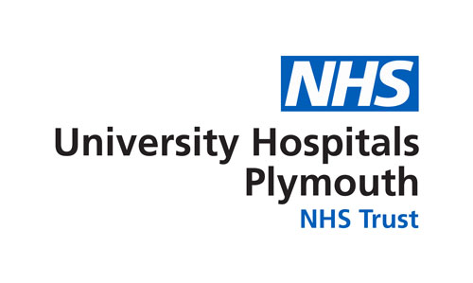

BRITISH ANTARCTIC SURVEY MEDICAL UNIT

Hyperbaric Medical Centre, Plymouth Science Park, Derriford, Devon, PL6 8BU, UK
Telephone 01752 315220 Fax 01752 315219
Email Clinical: matt.warner1@nhs.net, Admin: mike.dinn@nhs.net

Dental Self-Certification for Arctic Deployment

Name:

Date of Birth:

I declare that I have had a dental check in the last 6 months.

I have no known dental problems which will require treatment while I am deployed.

I am aware that should I develop a dental problem requiring treatment while I am deployed, this may impact on my program. (Liability for any costs incurred will be determined as per BAS policy and is outwith the remit of BASMU.)

Signed:

Date:

