SOUTH GEORGIA AND SOUTH SANDWICH ISLANDS (SGSSI) AREA
Environmental Impact Assessment and Permitting requirements
Introduction
All projects taking place in the South Georgia and the South Sandwich Islands (SGSSI) area require an environmental assessment which falls under the jurisdiction of the Government of SGSSI. This environmental assessment is achieved through a Regulated Activity Permit (RAP).
This guidance note explains how to apply online for a Regulated Activity permit (RAP) for projects taking place in SGSSI. From the 2021-22 season, all Principal Investigators (PI) are required to use the new online RAP application system.

Online process for the 2021-22 season
There are three categories of RAP application which vary depending on the complexity of the project. Please refer to the GSGSSI website for more information on GSGSSI RAP Categories. Environment Office can help you determine which category your project falls into. Most BAS projects will fall into Category 2.
The online forms are specifically tailored to BAS, which means that you will need to follow the following steps very carefully in order for the form to work properly.
Please follow the following steps carefully:
- Access the appropriate online form here (and not from the GSGSSI website):
Category 1: https://form.jotform.com/211052681435348
Category 2: https://form.jotform.com/211052706220338
Should you require a Category 3 application please discuss with Environment Office.
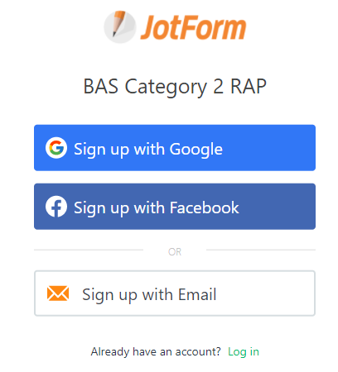
- When presented with the options below choose ‘Sign up by Email’. Use your work email address and make a note of the password you set so you can save and access your form at a later date.

- When populating the form, ensure that you enter your work email address with the organisation email domain ‘bas.ac.uk’. If you are non-BAS, please get in touch with the BAS Environment Team.
- Save your form regularly to avoid losing data.
- You can use and upload the sample collection spreadsheet.
- Save your form prior to submission.
- Submit your application.
- You should now see this confirmation on your screen: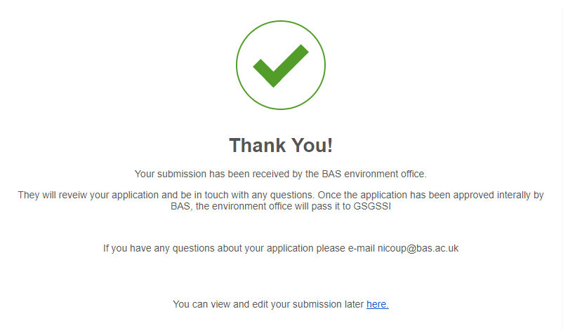

- You will receive a confirmation email titled ‘We have received your response for BAS Category 1/2 RAP’.

- If you need to edit your application at any stage, please use the "You can view and edit your submission later here" link at the bottom of your confirmation email or sign into your account using your work email and password (as detailed in step 2).

Environment Office will process your application and communicate with you as required. GSGSSI is responsible for final review and approval and will communicate the outcome of the permit application direct to the BAS PI.

